DBMS   
TOPIC 1:-

Introduction to DATABASE SYSTEM

Data: are raw facts indicating that facts have not yet been processed to reveal meaning.  
-Bedrock of knowledge that is the body of information and facts about a specific subject.  
-Constitute the building blocks of information.

Information: is the result of processing raw data to reveal its meaning.   
-Organizing data to reveal patterns.  
-Produced by processing data.  
-Used to reveal the meaning of data.

Knowledge: implies familiarity, awareness and understanding of information as it applies to an environment

Data management: is discipline that focuses on the proper generation, storage and retrieval of data.

What is database?

Database: collection of related data

Database Management Systems: software that manages and controls access to the database.

Database application: a program that interacts with the database at some point in its execution.

Database system: collection of application programs that interact with the database along with the DMBS.

Applications of Databases

1. Banking  
   -customer information account activities  
   -payment  
   -deposits  
   -loans
2. Airlines  
   -reservations  
   -schedule info
3. Universities  
   -student info  
   -course registrations  
   -colleges  
   -grades
4. Telecommunication.  
   -call records  
   -monthly bills  
   -maintaining balances
5. Finance   
   -storing info about stock  
   -sales  
   -purchase of financial instruments like stocks and bonds
6. Sales.  
   -storing customer.  
   -product  
   -sales information
7. Manufacturing  
   -management of supply chain  
   -tracking production of items  
   -inventories status in the warehouse
8. HR Management.  
   -info about employees  
   -salaries.  
   -payroll.  
   -deductions  
   -deductions  
   -generation of paychecks.

Traditional File-Based Systems

Adv. Of learning file based system

-Understand the problem inherent/coming from file-based systems (not to repeat previous mistakes).

-Understanding how file-base system works in case in conversion to database.

File-based Approach  
-it is the collection of application programs services for the end-user.  
-Each program defines and manages its own data.  
- It is a decentralized approach where each department with the assistance of Data Processing staff, stored and controlled its own data.

-Significant amount of duplication.

Terminologies of file-based:-

File: collection of records which contains logically related data.

Record: contains logically connected set of one or more fields.

Disadv of File-Based Approach  
❖ Separation and isolation of data: more difficult to access data that should be available.

❖ Duplication of data : uncontrolled duplication of data.  
-Wasteful (time and money)  
-Takes up space (costly).  
-Loss of data integrity(not consistent).

❖ Structural and Data dependence

-Physical structure/storage of the data files/ records are defined in the application code.  
-Making changes is difficult.  
-Access to file is dependent on its structure. (Structural dependence)  
-File system application programs are affected by change in the file structure.

Data dependence exists when changes to the data storage characteristics without affecting the applications program’s ability to access the data.

❖ Fixed queries/proliferation of application programs

-File-based systems are dependent upon the application developer (the one who writes queries or reports).  
-No asking for unplanned queries.

❖ Incompatible file formats

-structure is embedded in the application program therefore dependent on the application programming language.

❖ Lack of Design and Data-Modeling Skills

- Users typically lack the knowledge of proper design and data-modeling skills.  
-Important that a doc is created properly.  
-It is important to facilitate communication among the database designer, end user and the developer.

❖ There was no provision for security or integrity;  
-Recovery in the event of s/w and h/w failure was limited or non-existent  
-Access to files was restricted to one user at a time (no shared access by staff in the same department).  
-separate and unrelated files

Database Approach:

-The definition of the data is embedded in the application programs.  
-No control over access and manipulation of date beyond that imposed by application programs.  
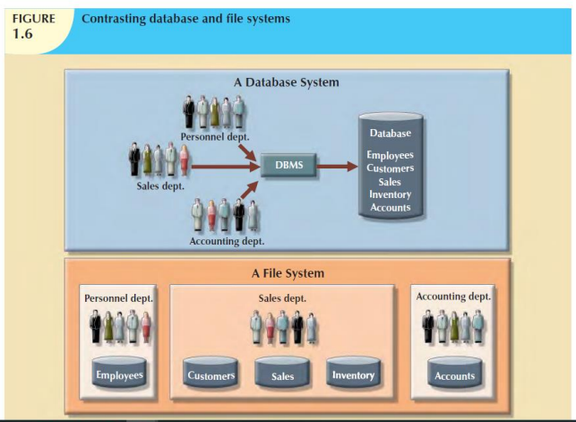

-Consists of logically related data stored in a single logical data repository.  
-A database is a shared, integrated computer structure that stores a collection of:

>End-user data  
>Metadata: data about data, end-user data are integrated and managed.  
-provide a description of the data characteristics and the set of relationships that links the data found within the database.

-Database and the Database Management System were emerged to become more effective.

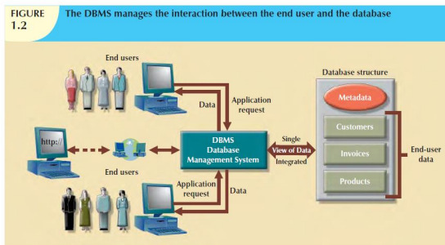

The Database: A shared collection of logically related data and a description of this data, designed to meet the information needs of an organization  
-database is single and can be used simultaneously by many departments and users. **-**Instead of disconnected files with redundant data, all data items are integrated with a minimum amount of duplication. **-**Shared corporate resource.  
-The database holds not only the organization’s operational data but also a description of this data.

Types of Databases

Classified according to:  
-number of users  
-database locations  
-the expected type   
-extent of the use  
-degree to which the data are structured.

1. Number of Users  
   -Single(desktop database) or  
    -Multiple users  
   >(workgroup database-limited no.of group)  
   >(enterprise database- entire organization).
2. According to database location   
   >Centralized database: local at a single site.  
   >Distributed database: across several different sites
3. The expected type and extent of use  
   Classifying db based on:  
   >How they will be used  
   >Time sensitivity of the information gathered from them  
   Operational/ transactional/production database: designed to support company’s day to day operations.  
   Data Warehouse: stores data used to generate information required to make tactical or strategic decisions.  
   > Data Massaging(Manipulation)   
   >Most decision support data are based on data obtained from operational databases over time and stored in data warehouses.  
   >Different structure from Operational db.  
   >data warehouse can store data derived from many sources.
4. According to degree to which the data are structured.  
   Classified to reflect the degree to which the data are structured.  
   >Unstructured data: re data that exist in their original (raw) state, that is, in the format in which they were collected.  
   -a format that does not lend itself to the processing that yields information  
   >Structured data: results of formatting unstructured data to store, use and generate info  
   >Semi-structured data: a are data that have already been processed to some extent.

The Database Management System (DBMS)

>It is the collection of programs that manages the db structure and controls access to data stored in db.  
>Stores relationships between those structures and the access paths to those structures—all in a central location.

• The DBMS is the software that interacts with the users’ application programs and the database. Typically, a DBMS provides the following facilities:   
o It allows users to define and modify the database   
o It provides controlled access to the database.   
o A security system, which prevents unauthorized users accessing the database;   
o An integrity system, which maintains the consistency of stored data;   
o A concurrency control system, which allows shared access of the database;   
o A recovery control system, which restores the database to a previous consistent state following a hardware or software failure;   
o A user-accessible catalog, which contains descriptions of the data in the database.

Role of the DBMS  
• The DBMS serves as the intermediary between the user and the database.   
• The database structure itself is stored as a collection of files, and the only way to access the data in those files is through the DBMS.   
• The DBMS presents the end user (or application program) with a single, integrated view of the data in the database.   
• The DBMS receives all application requests and translates them into the complex operations required to fulfill those requests.   
• The DBMS hides much of the database’s internal complexity from the application programs and users

DBMS provides advantages such as:  
• Improved data sharing. The DBMS helps create an environment in which end users have better access to more and better-managed data.   
• Improved data security. The more users access the data, the greater the risks of data security breaches. Corporations invest considerable amounts of time, effort, and money to ensure that corporate data are used properly.   
• Better data integration. Wider access to well-managed data promotes an integrated view of the organization’s operations and a clearer view of the big picture.   
• Minimized data inconsistency. Data inconsistency exists when different versions of the same data appear in different places.   
• Improved data access. The DBMS makes it possible to produce quick answers to ad hoc queries. From a database perspective, a query is a specific request issued to the DBMS for data manipulation—for example, to read or update the data. Simply put, a query is a question, and an ad hoc query is a spur-of-the-moment question. The DBMS sends back an answer (called the query result set) to the application.   
• Improved decision making. Better-managed data and improved data access make it possible to generate better-quality information, on which better decisions are based. The quality of the information generated depends on the quality of the underlying data. Data quality is a comprehensive approach to promoting the accuracy, validity, and timeliness of the data.   
• Increased end-user productivity. The availability of data, combined with the tools that transform data into usable information, empowers end users to make quick, informed decisions that can make the difference between success and failure in the global economy

(Database) Application Programs   
• Application program: A computer program that interacts with the database by issuing an appropriate request (typically an SQL statement) to the DBMS.   
• Users interact with the database through a number of application programs that are used to create and maintain the database and to generate information.   
• These programs can be conventional batch applications or, more typically nowadays, they will be online applications.   
• The application programs may be written in some programming language or in some higher-level fourth-generation language.

The Database System Environment

Database System: an organization of components that define and regulate collection, storage, management and use of data within a database environment.

It’s 5 parts:-

1. Hardware

-all physical devices, storage devices, printers, network devices.

1. Software

>operating system software: manages all hardware components and makes it possible for all s/w to run on the computers.  
>DBMS software: manages the database within the database system (eg SQL, Oracle, Sun’s MySQL)  
>application programs and utilities: access and manipulate data in the DBMS and to manage computer environment in which data access and manipulation take place.  
>Utilities: are s/w tools used to help manage database system’s computer components.

1. People

>Users:  
-system administrators: oversee db system general operation  
-database administrators (DBA) manages DBMS   
-database designers : Design structure of db.  
-system analysts and programmers: They design and create the data entry screens, reports, and procedures through which end users access and manipulate the database’s data.  
-end users   
>Naïve Users: Unaware of DBMS, they access thro special app programs  
>Sophisticated users: familiar with DBMS

1. Procedures: are instructions and rules that govern the design and use of the database system.  
   -they enforce the standards by which business is conducted within the organization and with customers.  
   -used to ensure that there is an organized way to monitor and audit both the data that enter the database and the information that is generated through the use of those data
2. Data: collection of facts stored in the database.

Advantages of the database approach:

-Control of data redundancy  
-Data Consistency  
-More information from the same amount of data  
-Sharing of data  
-Improved data integrity  
-Improved security  
-Enforcement of standards  
-Balance of conflicting requirements  
-Improved data accessibility and responsiveness  
-Improved maintenance through data independence  
-Increased concurrency  
-Improved backup and recovery services

Disadvantages

-Increased costs  
-Management Complexity  
Maintaining Currency  
Vendor Dependence  
-Frequency upgrade/replacement cycles